Promo Sanken HWD-Z78IC Water Dispenser Duo Gallon Cicil 0% 3x - Jakarta Barat - Sanken Official Store | Tokopedia
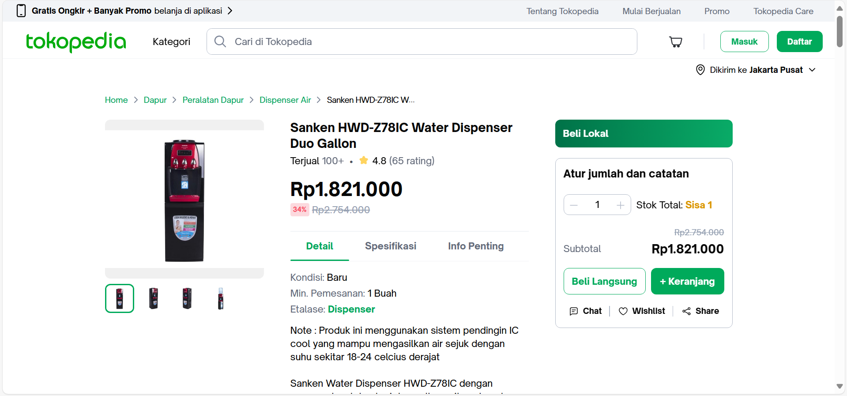
Sanken HWD-Z78IC Water Dispenser Duo Gallon

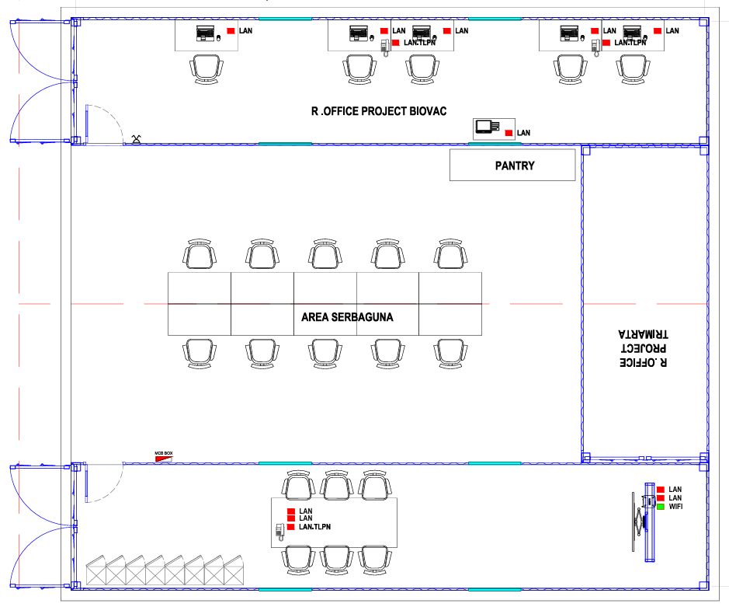
Dispenser

